1. **Ben Renick**
   1. According to Snapped, S32 E10, Ben Renick was born in 1987 (29-years-old) in Montgomery County, Missouri on a 40-acre family farm with brother, Sam. [Source 1]
   2. According to Snapped, S32 E10, Montgomery County Missouri is between St Louis and Colombia, on I70. [Source 1]
   3. According to Snapped, S32 E10, Sam, Ben’s brother, stated that Ben got his first snake when he was around12-years old. [Source 1]
   4. According to Snapped, S32 E10, when Ben was small, his mother was diagnosed with stage 4 breast cancer. Ben and Sam took care of each other. Ben’s mother stayed in stage 4 cancer for 15 years. [Source 1]
      1. According to Snapped, S32 E10, Sam stated that their mother taught them “resilience, self-sufficiency, and love.” [Source 1]
   5. According to Snapped, S32 E10, in 2008, their mother passed away.when Ben was 21 years old. [Source 1]
   6. According to Snapped, S32 E10, in 2012, Ben’s father, Frank, took his own life. [Source 1]
   7. According to Snapped, S32 E10, Ben started his reptile business in 2010 when he was 22-years-old. His vision was to produce designer pets with rare genetic patterns that nobody else had. [Source 1]
   8. According to CBS News, Ben sold his snakes to people all over the world, from the UK to Japan. [Source 5]
   9. According to St. Louis Dispatch, Bobbette Tucker, a family friend, described Ben as “a sweet, gentle, quiet” person. She said “He spent hours and hours there (snake business). That was his passion.” [Source 6]
   10. According to Snapped, S32 E10, when Ben was 24-years-old, he reconnected with an old friend, 23-year-old Lynlee Joe Gallatin. [Source 1]
   11. According to Oxygen True Crime, Ben’s friend Richie Berck said, “Ben was a successful snake breeder. He was kind of a pioneer in that whole industry. He was definitely well-known in the snake breeding community. Like I would say worldwide.” [Source 4]
2. **Lynlee Gallatin-Renick** 
   1. According to Snapped, S32 E10, Lynlee was born in 1988 in Wellsville, Missouri. [Source 1]
   2. According to Snapped, S32 E10, Sam stated that Lynlee was “sweet and bubbly”. [Source 1]
   3. According to Snapped, S32 E10, Lynlee’s mother was ill in her childhood and her father took care of her. Ben and Lynlee both grew up with the commonality that both their mothers were ill. [Source 1]
   4. According to Snapped, S32 E10, after graduating high school, Lynlee attended massage school. [Source 1]
   5. According to Snapped, S32 E10, on the day she was supposed to take her boards she discovered she was pregnant. The father left, and she was planning to raise her son on her own. [Source 1]
   6. According to Snapped, S32 E10, Lynlee met Ben in 2011. Sources say their relationship progressed quickly, and Ben moved her and her son to his farm. Shortly after they had their first child together. [Source 1]
      1. According to CBS News 48 Hours, attorney Katherine Berger stated, “I think they moved in together within the first year of dating.” [Source 3]
   7. According to Snapped, S32 E10, Sam said Ben was a good father. [Source 1]
   8. According to Snapped, S32 E10, Lynlee paused her career to help Ben with his reptile business. [Source 1]
   9. According to The U.S. Sun, Ben and Lynlee married on April 13, 2014. [Source 2]
   10. According to Snapped, S32 E10, in 2016, Ben’s snake business was very successful, so they decided that Lynlee could open Ascensia Spa in nearby Columbia. Ben made large investments up front to get the spa running. [Source 1]
   11. According to CBS News 48 Hours, Sam stated Ben planned to sell most of his ball python collection. He believed it was worth around $1.2million, and the couple had already received the first payment of $200,000. [Source 3]
3. **Leading up to the crime**
   1. According to Snapped, S32 E10, the marriage went through a tumultuous period. [Source 1]
   2. According to the Columbia Daily Tribune, Lynlee learned that her husband was planning to file for divorce and feared he might take their children. [Source 5]
4. **The crime occurs or is discovered**
   1. According to Snapped, S32 E10, on June 8, 2017 at 6:36 pm, Lynlee initially called her brother-in-law, Sam, urging him to get to the barn immediately. She told him that Ben was lying face down in a pool of blood. Sam rushed to the barn to understand what had happened. They believed Ben had been attacked by one of his snakes. As Lynlee tried to speak with 911, she became hysterical and handed the phone to Sam. They were calling from Ben’s rare snake breeding facility, Renick Reptiles, Inc. which housed around 3,000 to 4,000 snakes. [Source 1]
      1. According to CBS News 48 Hours, coroner David Colbert told “48 Hours”, “Someone being killed by a snake is not something that happens every day, especially in Missouri.” [Source 3]
      2. According to Snapped, S32 E10,, Missouri State Highway Patrol Master Sergeant, Darrin Haslag, stated “We got the call there was a man dead. It was suspected that it could have been a snake that’s loose in the facility. And the facility had somewhere between three and four thousand snakes. So, it’s a little unnerving not knowing what you’re going to walk in on.” [Source 1]
      3. According to CBS News 48 Hours, the police were holding guns and were very anxious about all the snakes in the building. [Source 3]
   2. According to Snapped, S32 E10, when Sam entered the building, he found Ben on the ground covered in blood. [Source 1]
   3. According to The U.S. Sun, Lynlee first told police that Ben was crushed by one of the python’s from the facility. [Source 2]
   4. According to Snapped, S32 E10, when the EMTs arrived and rolled him over, they discovered a shell casing. Ben had been shot in the back several times and the back of the head. At that time, it was determined to be a homicide. [Source 1]
5. **Investigation**
   1. According to Snapped, S32 E10, Renick Reptiles is a large, two-story barn with concrete floors and rows of plastic containers, each housing snake after snake. [Source 1]
   2. According to Snapped, S32 E10, Ben’s brother, Sam, said “everybody loves Ben.” [Source 1]
   3. According to Snapped, S32 E10, police reported that Lynlee was crying and screaming in her car. Detective asked her to come down for an interview. She agreed. [Source 1]
   4. According to Snapped, S32 E10, several shell casings were found underneath Ben’s body, along with small divots in the floor - evidence that he had been shot multiple times after collapsing. The police reported discovering four or five shell casings. [Source 1]
   5. According to Snapped, S32 E10, the Coroner reported that Ben was shot eight times from behind with the majority of bullets coming after he hit the floor. Ben likely died within 2 hours of the call to 911. [Source 1]
   6. According to Snapped, S32 E10, there was no security on the property. Ben had large amounts of cash in different places on the property so the police initially thought it may have been a robbery gone bad. [Source 1]
   7. According to Snapped, S32 E10, Lynlee reported that she spent the day working in Columbia at her spa. [Source 1]
   8. According to Snapped, S32 E10, at 3:45 pm Lynlee communicated with Ben via text regarding picking up the children and he did not answer. [Source 1]
   9. According to Snapped, S32 E10, at 6:00 pm, Lynlee received a call from the school saying Ben had not picked up the kids. [Source 1]
   10. According to Snapped, S32 E10, Lynlee reported that since she was unable to reach Ben, she took off to pick up the kids. [Source 1]
   11. According to Snapped, S32 E10, Lynlee told the police she had a weird feeling because Ben had never forgotten the kids before. After arriving at home, she told the kids to stay in the car and she went to the barn to check on him. Lynlee found Ben on the ground with a lot of blood. She stated that she ran out and called Sam. [Source 1]
       1. According to Snapped, S32 E10, Lynlee reported that she called Sam first because he was on the property. [Source 1]
   12. According to Snapped, S32 E10, Devin Foust, Missouri State Highway Patrol Investigator, said she seemed “forthcoming and willing to help.” [Source 1]
   13. According to Snapped, S32 E10, when asked if there were any family issues, she replied “yes”. She said that when Ben’s father shot himself, she and Ben ended up owning all the property, which upset brother Sam. [Source 1]
       1. According to Oxygen True Crime, Lynlee said “Sam kind of basically just went to Ben and he was like, ‘You need to give me half of the property.’ Ben was like, ‘No, I can’t jeopardize my family and this business.’ So, you know, he just said a lot of really hurtful things to Ben.” [Source 4]
       2. According to Snapped, S32, E10, Sam stated “It wasn’t an equal inheritance. But it is what it is. Life’s not fair. I can’t afford the farm. That’s an expensive place to live”. [Source 1]
       3. According to CBS News 48 Hours, at the time of the murder, Sam and Ben were living in separate houses with their families on the 70-acre farm. [Source 3] Sam stated “we lived out there together. And raised our kids out there together. The - we went fishing on the weekends and - you know, we were close.” [Source 3]
   14. According to Snapped, S32 E10, when investigators asked Sam if he had anything to do with the murder, Sam replied “no”. Police seized Sam’s shirt, downloaded his phone, and said they wanted to polygraph him. [Source 1]
   15. According to Snapped, S32 E10, police asked Lynlee to do an inventory on the snakes to see if any snakes were missing. She did not believe any were missing. There is also no proof that cash is missing. Nothing is apparently stolen, so robbery is taken off the table as motive. [Source 1]
   16. According to Snapped, S32 E10, days later, Sam came to Jefferson City and took the polygraph test, to which he passed. Police confirmed Sam’s alibi that he was at work. Sam is removed as a person of suspicion. [Source 1]
   17. According to Snapped, S32 E10, Sam said his brother had no enemies, but his father did. [Source 1]
       1. According to Snapped, S32 E10, Sam stated his father owned his own pet food company in Montgomery county. He said “he mismanaged the company and had defrauded many people out of investments.” In 2012, he was indicted by a federal grand jury for fraud for taking investors money and not putting it into the business. Shortly after, he took his life. Police began to wonder if upset investors may be a motive for the murder. [Source 1]
          1. According to Snapped, S32 E10, police obtain a search warrant and begin looking at Ben’s social media accounts for potential threats. They did not find anything to back up this theory. [Source 1]
   18. According to Snapped, S32 E10, police did find evidence that the marriage was having issues. Ben and Lynlee communicated with each other via text and Facebook Messenger (20 thousand + pages). [Source 1]
       1. According to Snapped, S32 E10, police find evidence that Ben thought Lynlee was cheating on him. [Source 1]
       2. According to Snapped, S32 E10, Ben said she was on her phone a lot or taking her phone to the bathroom. [Source 1]
       3. According to Snapped, S32 E10, Lynlee met a local man, Aric Bremmer, on a dating site. Bremmer was a marketing professional who said he would help her with her business occasionally. They would meet around twice per month. [Source 1]
          1. According to Snapped, S32 E10, police talk to Aric. He had an alibi, he was on a trip with friends. This was verified by police and Aric was no longer a suspicious person. [Source 1]
       4. According to Snapped, S32 E10, police suspected that it may not be the only affair that Lynlee was involved with. They reviewed her phone records and found many messages and calls to 34-year-old Brandon Blackwell. [Source 1]
          1. According to Snapped, S32 E10, police interview Brandon. He states they met on the dating site. [Source 1]
          2. According to Snapped, S32 E10, Brandon admits they had started a sexual affair three days before the murder. Brandon also has an alibi. He worked at a power plant company and police verified he was at work. Therefore, Brandon was no longer a suspicious person. [Source 1]
6. According to Snapped, S32 E10, on June 19, 2017 (11 days after murder), police asked Lynlee to come back in. They asked if they could view her text messages and she agreed. [Source 1]
   1. According to Snapped, S32 E10, police find text messages on the day of the homicide with her and a “Mike H”. They stated they talked the whole day of the murder, but haven’t talked since. [Source 1]
   2. According to Snapped, S32 E10, police asked Lynlee “who is ‘Mike H’”? She responded, “Michael Humphrey.” Lynlee said he was a client she used to work on at her massage business. When police asked why she was contacting him, she said it was random, but her boss, Ashley Shaw, had asked if she knew anybody that did car audio work. Lynlee suggested Michael Humphrey to her. [Source 1]
      1. According to CBS News 48 Hours, Michael was an ex-con just out of prison on drug possession charges. [Source 3]
      2. According to Snapped, S32 E10, Lynlee seemed taken aback as police asked more questions about Michael, so they decided they needed to learn more about Mike. [Source 1]
      3. According to Snapped, S32 E10, police set up a meeting with Mike on July 17, 2017. When asked how he knows Lynlee, he stated they used to date several years back, and she and her boss, Ashley Shaw, were driving through his trailer park and saw him. It had been around seven years since he had seen her. He said Ashley wanted some stereo equipment put in. [Source 1]
         1. According to Snapped, S32 E10, police did not understand this. Police stated “there are many people who could install stereo equipment rather than a boyfriend you haven’t seen for years.” [Source 1]
         2. According to Snapped, S32 E10, despite suspicions about Mike, police let him go. [Source 1]
   3. According to Snapped, S32 E10, police go back to text messages between Ben and Lynlee. [Source 1]
      1. According to Snapped, S32 E10, police realized many of the messages were about money or their relationship. [Source 1]
         1. According to Snapped, S32 E10, Lynlee was not paying her business loan on time. [Source 1]
         2. According to Snapped, S32 E10, Lynlee owed an electric company around $5,000. [Source 1]
         3. According to Snapped, S32 E10, Lynlee owed an architecture around $5,000. [Source 1]
         4. According to Snapped, S32 E10, Ben began learning about this through emails from her bank. [Source 1]
         5. According to Snapped, S32 E10, they found that Ben was paying a lot of the bills for Lynlee’s business. [Source 1]
         6. According to Snapped, S32 E10, the financial strain drove a wedge between them, raising questions about whether it could be a motive for murder. [Source 1]
      2. According to Snapped, S32 E10, after learning that Lynlee was a suspect, an insurance agent called the police and said they are handling the Renick policy. The investigative specialist asked if Lynlee was a suspect in the case. Police stated she was so the insurance company said they had paused paying Ben’s 1 million dollar life insurance policy. [Source 1]
         1. According to Snapped, S32 E10, the insurance specialist says Lynlee started trying to cash in the policy within 12 hours of Ben’s death. Police believe this to be suspicious. [Source 1]
         2. According to Snapped, S32 E10, the life insurance payout was never made to Lynlee. [Source 1]
      3. According to Snapped, S32 E10, in the months following Ben’s death, police find Lynlee has also been trying to sell the farm and Ben’s snake business. Sam steps in to try and stop the sale. They have to go to court to figure out all the assets. [Source 1]
      4. According to Snapped, S32 E10, Lynlee wins the farm settlement. Ben was the sole owner of the farm, but when he passed it went to Lynlee, solely. Sam lost the farm his family had lived on for 40 years. [Source 1]
         1. According to Snapped, S32 E10, in 2018, Lynlee proceeded with the sale of the property weeks after the murder and received about $740,000. That same year, Lynlee moved to Columbia with Brandon and her three kids. [Source 1]
      5. According to Snapped, S32 E10, on October 5th, investigators tell Lynlee they need to talk to her again. They explain a polygraph may be a way to exclude her as a suspect and Lynlee agrees. Lynlee fails the polygraph test. She then said she wanted a lawyer so questioning stopped. Lynlee remained free for almost three years. [Source 1]
      6. According to Snapped, S32 E10, over the next couple months, Lynlee continues to fight Sam over the sale of the farm. [Source 1]
      7. According to Snapped, S32 E10, in a short amount of time, Lynlee goes public with her relationship with Brandon Blackwell. Sam learns of this via her social media accounts. Brandon was married and had two kids. Shortly after, they find out she was pregnant. He left his wife and they had the child together. [Source 1]
      8. According to CBS News 48 Hours, the reptile community stepped in to help and raised more then $40,000 for Ben’s wife and children with an online auction. [Source 3]
      9. According to Snapped, S32 E10, Brandon and Lynlee’s relationship was rocky. In 2019, Lynlee decided she had enough and got a restraining order against Brandon. [Source 1]
         1. According to Snapped, S32 E10, in 2020, Brandon was arrested for violating that order. He was sent to the Boone County jail. [Source 1]
      10. According to Snapped, S32 E10, when Brandon was in jail, he asked to talk to the police. Brandon told police that Lynlee would tell him pieces of what had happened. According to Brandon, in the days before Ben’s death, Lynlee made her first attempt to kill Ben. He said her co-worker, Ashley Shaw, helped Lynlee to obtain narcotics (Percocet) and come up with a plan to poison Ben. They crushed up the pills in a protein shake, but the attempt failed. Ben’s Facebook message stating he had become sick from his protein shake confirmed Brandon’s story. [Source 1]
          1. According to Snapped, S32 E10, when the first attempt didn’t work, Lynlee reached out to Michael Humphrey.
          2. According to CBS News 48 Hours, Brandon stated to police, “They drove to the farm, he had gloves, he had a firearm, the plan was for him to do it. They get there he hands her the gun and says he doesn’t feel comfortable doing…it’s something she’s gotta take care of. She walks in with the gun…and just shoots him a bunch of times.” [Source 3]
          3. According to Snapped, S32 E10, police said Brandon should not have known these facts unless he was told by Lynlee. [Source 1]
      11. According to Snapped, S32 E10, two days after the interview with Brandon, police arrest Michael Humphrey. [Source 1]
      12. According to Snapped, S32 E10, in the interview, Michael Humphrey said Lynlee told him Brandon would hit her and get out of control. Michael believed it and wanted to help. [Source 1]
          1. According to Snapped, S32 E10, Michael brought a gun to the spa in case she needed it. [Source 1]
          2. According to Snapped, S32 E10, two weeks later she asked Michael to go with her to see Ben. She said she was leaving him and needed to get her stuff and wanted Michael there in case he flipped out on her. [Source 1]
          3. According to Snapped, S32 E10, Michael introduced himself to Ben. They entered the barn. Michael said he was barely in the door when he first started to hear shots. He turned and ran out the door when he heard the first shot. Michael stated he heard five shots, maybe another one or two following the first round. As Lynlee came running out of the barn, he said “What the f— just happened?” Lynlee said “We gotta go, we gotta go.” They took off in his car. Michael would not tell police what they did with the gun following the murder. [Source 1]
          4. According to Snapped, S32 E10, that same day, police arrested 29-year-old Ashley Shaw. While she is waiting, her attorney shows up. They both say, “we will tell you the story if you give us that immunity.” [Source 1]
             1. According to Snapped, S32 E10, Ashley Shaw is granted immunity if she agrees to testify against Lynlee and Michael Humphrey. [Source 1]
             2. According to Snapped, S32 E10, Ashley said she agreed to help Lynlee because she said she was in an abusive relationship. [Source 1]
             3. According to Snapped, S32 E10, Ashley admitted she was the one that got the percocet. She also was the one to find Michael Humphrey. [Source 1]
             4. According to Snapped, S32 E10, when Lynlee went to the farm, Ashley stayed behind to establish her alibi. Lynlee left her phone with Ashley, instructing her to send texts and messages to make it appear as though she was at the spa. Ashley continued texting and trying to call Ben, but he never answered-because he was already dead. [Source 1]
7. **Arrest**
   1. According to Snapped, S32 E10, on January 16, 2020 (2 ½ years after Ben’s death) police finally have the information they need to arrest Lynlee and Michael Humphrey. She was arrested at her home in Columbia. Lynlee refused to make a statement. [Source 1]
8. **Trial**
   1. According to Snapped, S32 E10, Michael’s trial began in October 2021. [Source 1]
   2. According to Snapped, S32 E10, Michael claims he didn’t pull the trigger. The law says that you don’t need to be the one who pulled the trigger. If you were aware of the crime or participated in it, you are just as guilty as the person who actually fired the shot. [Source 1]
   3. According to The U.S. Sun, the jury did not believe him, and Michael was convicted of first-degree murder on January 5, 2022 and was sentenced to life in prison without the possibility of parole. [Source 2]
   4. According to Snapped, S32 E10, as they prepared for Lynlee’s trial, Michael’s attorneys contacted the police and said he would show the police where the gun is. Troopers found it in the attic under the insulation. They took it to the lab and realized they had the murder weapon. [Source 1]
      1. According to Snapped, S32 E10, Michael agreed to testify at Lynlee’s trial if they removed his first-degree murder conviction and gave him second-degree murder and sentenced him to life in prison with the possibility of parole. [Source 1]
   5. According to Snapped, S32 E10, in December 2021, 33-year-old Lynlee Renick went to trial and testified on her own behalf. [Source 1]
   6. According to Snapped, S32 E10, Lynlee stated that it was Michael Humphrey who pulled the trigger. She stated she was there and didn’t know it was going to occur. Michael and Ashley testify to the contrary. [Source 1]
   7. According to CBS News 48 Hours, Prosecutor Kelly King painted Lynlee like one of Ben’s snakes, a cold-blooded killer. She states, “She goes to school, picks up her two children, and drives them back to the place where she knows she is going to find their father’s dead body because she killed them.” [Source 3]
   8. According to CBS News 48 Hours, Ashley Shaw states that Lynlee goes back to the spa. When Prosecutor Kevin Zoellner asked why, she said “To give her a shower…and she asked me to scrub her body and her hands really well.” [Source 3]
   9. According to The U.S. Sun, after a four day trial, the jury begins deliberation. On December 9, 2021, after 12 hours of deliberating, a jury found Lynlee guilty of second-degree murder and armed criminal action. She was given a 16-year sentence on January 24, 2022. [Source 2]
   10. According to CBS News 48 Hours, Judge Crane stated to Lynlee, “You’re awful lucky ma’am. You’re gonna get out in your 40’s. And my 40’s weren’t too bad. I just hope you don’t kill again. That’s it.” [Source 3]
9. **Where are they now?**
   1. According to The U.S. Sun, Lynlee is incarcerated at Chillicothe Correctional Center. [Source 2]
   2. According to The U.S. Sun, Michael’s sentence of first-degree murder was reduced to second-degree murder with a life sentence. He is incarcerated at Jefferson City Correctional Center. [Source 2]
10. **Aftermath**
    1. According to CBS News 48 Hours, in talking about the motive, Sam Renick stated that Lynlee stood to gain millions from Ben’s death. With the life insurance payout, the sale of the snakes, and the inheritance of the family farm, she would receive a substantial amount. [Source 3]
    2. According to CBS News 48 Hours, Sam Renick is taking care of Ben’s children for the rest of their lives. [Source 3]
    3. According to Oxygen True Crime, Sam Renick stated, “He {Ben) would have had a long, beautiful life, and that was stolen from him. Those kids deserved a father, and they were denied that. And the ripple effects of his murder will span generations.” Sam continues to say “We were happy that she was sentenced to the 16 years she was given, however, my brother’s life was worth a lot more than 16 years. Those children. All the lives that were destroyed by this, by these actions.” [Source 4]
    4. According to CBS News 48 Hours, Ben Renick lives on, celebrated with a new breed of snake named after him, The Renick Ghost. [Source 3]

Sources:

1. <https://www.peacocktv.com/watch/playback/vod/GMO_00000000391396_01/da9b028c-cff7-3f40-a085-4d4e3a7ad1a6>
2. <https://www.the-sun.com/news/4872452/who-is-lynlee-renick/#:~:text=Lynlee%20Gallatin%2DRenick%20is%20a,inmate%20from%20New%20Florence%2C%20Missouri>.
3. <https://www.cbsnews.com/news/ben-renick-missouri-reptile-breeder-murdered-lynlee-renick-48-hours/>
4. <https://www.oxygen.com/snapped/crime-news/lynlee-renick-murdered-husband-ben-for-farm-life-insurance>
5. <https://www.newspapers.com/image/1023243217/?match=1&terms=lynlee%20renick>
6. <https://www.newspapers.com/image/629566441/?match=1&terms=lynlee%20renick>
7. <https://www.facebook.com/search/top?q=ben%20renick%20reptiles>

Photos:

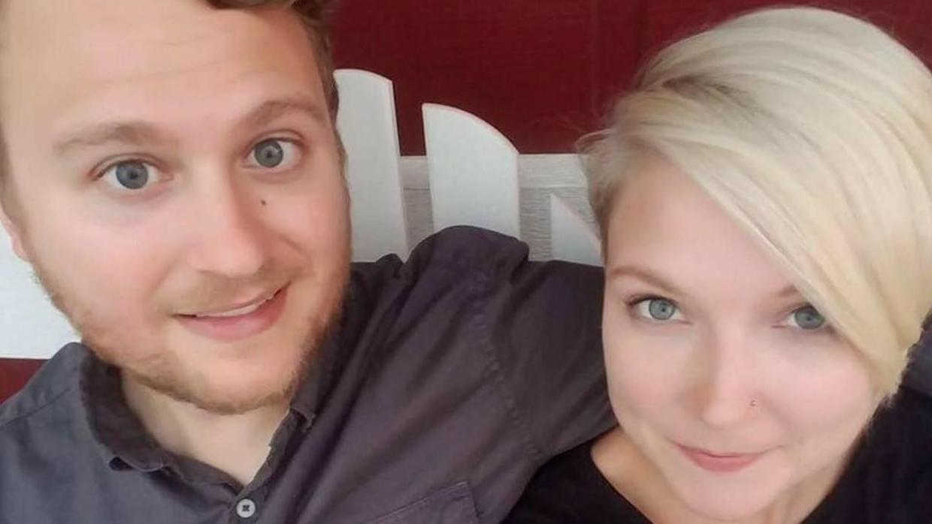

CBS News 48 Hours taken from Ben Renick’s Facebook page, Ben and Lynlee Renick [Source 3]

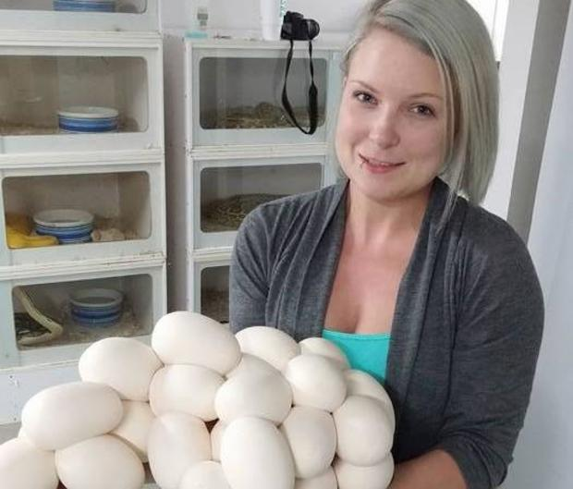

Ben Renick/Facebook, Lynlee Renick helped her husband at his snake breeding facility. She is seen holding snake eggs. [Source 7]

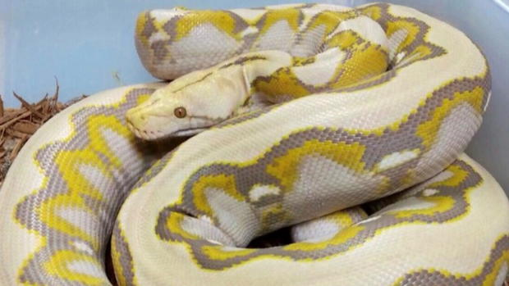

CBS News 48 Hours, The Renick Ghost [Source 3]