- Background on Kadin Black
  - According to NBC News Dateline, Kadin Black was a 19-year-old from Wrightsville, Pennsylvania. [source 1]
  - According to NBC News Dateline, Kadin was raised by his mother, Kara Patterson, with four siblings, two older and two younger, in Wrightsville, Pennsylvania. [source 1]
  - According to NBC News Dateline, Kadin has dark brown hair and brown eyes. He is 5’10” and has an athletic build. He weighs around 160 lbs. It was not known what he was last wearing but Kara said he normally wears dark clothing and white sneakers. [source 1]
  - According to NBC News Dateline, Kadin’s parents divorced when he was three years old. [source 1]
  - According to NBC News Dateline, Kara received a promotion for work in 2019. She moved to Maryland with Kadin and his two younger siblings. [source 1]
    - According to NBC News Dateline, Kadin told his mother he missed his friends and life in Pennsylvania, so in November 2021 he moved back to Wrightsville to live with his father, Maurice Black. [source 1]
    - According to NBC News Dateline, Kara stated that Kadin got into a fight with his father in September 2022 and moved in with his friend Ethan Foust and his family. Maurice went on to say his son was “at that age where I can’t tell him where he can and can’t live. So, I have to let him be his own man.” [source 1]
    - According to NBC News Dateline, Maurice says he and his son would see each other often. Kadin visited his father on Sundays so he could walk his dogs. [source 1]
  - According to NBC News Dateline, Maurice described his son as a “community helper.” Kadin was starting his own lawn care business. [source 1]
  - According to NBC News Dateline, Kadin loved animals. Kadin had two pit bulls that according to Kara, “…he used to run and love on them all the time.” [source 1]
  - According to NBC News Dateline, Kadin was described by his caretaker, Chris Foust, as a great kid. He stated, “We talked a lot, we spent a lot of time together.” He continued saying they “Road bikes together, just hung out, worked on vehicles together.” [source 1]
  - According to NBC News Dateline, Kara Patterson described Kadin as extremely athletic. She states, “He would go to the gym, you know, at least every other day – if not every day – and lift weights and work out.” [source 1]
  - According to News Nation, Kara said, “He had the greatest laugh, I mean, it was deep.” She stated, “He would hold his stomach and bend over, he would laugh so hard.” [source 2]
  - According to the The Charley Project, Kadin was attending an alternative school for kids with social, emotional and/or behavior problems. [source 6]

- Leading up to Kadin going missing
  - According to NBC News Dateline, Kara last spoke with her son on Wednesday, December 14th of 2022. She stated they had been talking about Christmas plans. “He was gonna come and stay at our house Christmas Eve to wake up here Christmas morning.” She said, “We were talking about, you know, bedroom arrangements.” She didn’t think anything seemed out of the ordinary when speaking to her son. [source 1]
  - According to NBC News Dateline, Maurice Black spoke with his son on Saturday, December 17th of 2022. He told his father he would be there the next day to take the dogs out. [source 1]
  - According to NBC News Dateline, Maurice began to worry when Kadin did not show up to his home on Sunday, December 18th of 2022. [source 1]
  - According to NBC News Dateline, on Monday, December 19th of 2022, Maurice called Ethan Foust’s father, Chris, to check on Kadin, but he was unable to reach him. [source 1]
  - According to NBC News Dateline, Kara received a phone call from Chris Foust on Tuesday, December 20th of 2022. Chris asked if Kara had seen Kadin and she said they had not seen him since Saturday, December 17th of 2022. Following this conversation, Chris reported Kadin missing to the Windsor Township Police Department. [source 1]
  - According to NBC News Dateline, Chris stated, it was “not an abnormal thing”. Kadin and Ethan would “go out all night, come home and sleep all day, and repeat it.” But on Tuesday, December 20th of 2022, he became worried that nobody had seen Kadin. [source 1]
  - According to NBC News Dateline, Chris stated that Kadin’s demeanor had changed about two weeks before he went missing. Normally, he would hang out with the family. However, Chris says, “He would come home and just go straight to his room and not come out like he used to.” [source 1]
  - According to NBC News Dateline, Kadin started working at a local moving company. His family reported that Kadin had gone to the home of a co-worker days prior to his disappearance. Kara visited the home of this co-worker after Kadin vanished to see if he had any information. The man told her that he didn’t know Kadin. [source 1]
  - According to News Nation, Kadin was arrested for having a fight with his school bus driver. He had an upcoming court hearing at the end of January 2023, but the family felt he would be exonerated. [source 2]
    - According to The Charley Project, his mother believes this could be a possible motive for his disappearance. [source 6]
    - According to News Nation, Kadin had told his mother that he was not going back to jail. [source 2]
  - According to News Nation, Kara said Kadin experienced mental health challenges, such as bipolar disorder, oppositional defiant disorder, and autism. [source 2]

- Investigation
  - According to NBC News Dateline, both the York County District Attorney’s office and Lower Windsor Township Police Department are investigating the disappearance. [source 1]
  - According to NBC News Dateline, Chief James Thomas and Scott James, Chief County Detective for the York County District Attorney’s Office described the search efforts as exhaustive. [source 1]
  - According to NBC News Dateline, the search encompasses a five-to-six-mile radius, which is where Kadin’s cell phone last pinged. [source 1]
    - According to NBC News Dateline, Chief Thomas stated they were not able to locate the cell phone, but they were able to obtain Kadin’s cell phone data via a warrant. [source 1]
    - According to News Nation, the family and police believe the cell phone may hold the key to the investigation. [source 2]
    - According to NBC News Dateline, Chief Thomas mentioned that they have conducted searches by air, land, and water with help from various local agencies and organizations specializing in rescue operations. Unfortunately, they did not find anything significant during these searches. [source 1]
  - According to NBC News Dateline, Chief Thomas stated “We checked video cameras in the area and doorbell cams. We’ve checked businesses. We have very little to go on.” [source 1]
  - According to NBC News Dateline, Detective James said they searched for Kadin in December. He stated, “it was adverse weather.” “There was snow and ice, and the river was frozen over.” He said that they continued to search for Kadin over the winter and have performed follow up searches since then. [source 1]
  - According to NBC News Dateline, Kara is thankful for the work the police have done but believes more can be done. She stated, “I don’t think that they’ve ever handled anything like this. It’s a small town, you know? It’s a small police station.” [source 1]
  - According to NBC News Dateline, Chief Thomas stated the disappearance “affected us on a personal level.” He had been Kadin’s high school track coach. He continues, “We all knew Kadin. We all got along with Kadin. There’s been many a night we sat around the squad room brainstorming and trying to figure out what happened.” [source 1]
  - NBC News Dateline reported that Chief Thomas stated, “Every lead that we get, we run down and have not been able to come up with some sort of trail.” He said, “It’s like he just disappeared into thin air.” [source 1]
  - NBC News Dateline reported that Chief Thomas is puzzled by the disappearance. He stated, “We had a perfectly physically fit young man. Basically, one night he’s in the house and the next morning he’s not there.” Early in the investigation he reported, “We don’t have anything pointing specifically to foul play. And we don’t have anything specific about any sort of accident or self-harming or anything like that. It’s just – it’s just a big question mark.” [source 1]
    - NOTE Chief Thomas makes a contradictory statement: News Nation reported that Chief Thomas stated, “During the course of the investigation and looking into things, we feel that there’s a possibility of foul play.” [source 2]
      - CBS21 reported Chief Thomas said they didn’t have proof of bad things happening but thought it could be a “possibility.” [source 3]
    - Kara Patterson said to CBS21, “I think it’s ridiculous. It was always possible.” She said “I have felt it was foul play the whole time because the facts in Kadin’s case don’t make sense. You don’t put your paycheck in the bank if you’re gonna run away or disappear on your own. He put his check in the bank on Friday – account hadn’t been touched. He didn’t take anything with him.” [source 3]
  - According to York Dispatch, Black’s cell phone was pinged on Tuesday, December 20th of 2022 to help locate him. It showed it was 2.4 miles from the cell tower on Old Commons Road, which is in Windsor Township. Officers searched the area on December 22nd of 2022 but were not able to locate the phone. [source 4]
    - According to News Nation, police thought Kadin disappeared Saturday night, December 17th of 2022, or the early hours of Sunday, December 18th of 2022. However, Chris Foust reported that “Kadin’s cellphone was still connected to their WiFi at 9:33 a.m. Sunday morning, December 17th of 2022.” [source 2]
  - According to York Dispatch, the only articles Black took with him were his cellphone and wallet. Chief Justice stated he also deleted several platforms on social media at that time. [source 4]
  - According to CrimeWatch media post, The Lower Windsor Township Police Department said they are still looking into the case. They’ve talked to lots of people like friends, family, supervisors, coworkers, and people who live nearby. [source 7]
  - According to CrimeWatch media post, up until now, there haven’t been any believable sightings of Kadin since he disappeared in December 2022. [source 7]
  - According to CrimeWatch media post, the authorities are treating the case as a missing person investigation, not a criminal incident. [source 7]
  - According to NBC News Dateline, Kara Patterson said, “Somebody knows something.” She stated, “Maybe they don’t know that they know somebody – or that they know something.” Maurice Black said he just wants his son home stating “My doors are always open.” [source 1]

- What is happening now?
  - According to News Nation, a Facebook page has been set up, “Find Kaden Black”, for followers to gain additional information and keep Kadin’s name out there. [source 2]
  - According to News Nation, the family is also working with the Doc Ellis Foundation, an organization created in honor of Doc Ellis, Pittsburg Pirates pitcher, to assist minority families with missing loved ones. [source 2]
  - According to York Dispatch, lots of groups have helped Lower Windsor Police since Kadin went missing. These include Center for Missing and Exploited Persons, Crimestoppers of PA, Team Adam, South Central Search and Rescue, York County Sheriff’s Office Drone Division, York County Emergency Management, Craley Fire Company, East Prospect Fire Company, Lake Clarke River Rescue, PA State Police Missing Persons Unit and Air Team and the National Child Protective Task Force. [source 4]
  - According to Fox32, Kadin’s brother, Carter Black, stated almost one year after his brother went missing, “Just a simple ‘Hey Mom, I’m safe. I’m fine. I’m okay.’ And he could hang up the phone.” He said, “I think that would start pushing my mom in a better direction, pushing the whole family in a better direction.” [source 5]
  - According to York Dispatch, police still need help in locating Kadin. Chief Thomas stated, “We are very concerned for his welfare and well-being.” Thomas said, “He’s not in any trouble with the police; in fact, we’ve always had a very nice relationship with Kadin. We would like to find him and put the family’s mind at ease.” [source 4]
  - According to NBC News Dateline, Kara and Maurice are reminded often how empty their life is without Kadin. Kara stated, “We just need him home because it’s just, it’s like a big hole, an emptiness.” She proudly stated, “He would come in the house and hew wouldn’t say ‘Hi.’ He would say, ‘Ayeeeeee.’” Maurice said, “He [has] such a great smile, you know.” [source 1]
  - According to NBC News Dateline, Chief Thomas stated, “I think we’re past asking. I don’t want to say begging, but we’re, you know, we’re asking really, really hard: If anybody has any information or any tip that might be helpful to us, get it to us.” [source 1]
  - According to News Nation, contact the Lower Windsor Township Police Department at 717-244-8055 if you have any information related to the disappearance of Kadin. [source 2]

Sources:
- Portney, Sarah, NBC News Dateline, “It’s just a big question mark…”, April 12, 2023
- O’Toole, Cathleen, Hughes, Marni, News Nation, “Kadin Black vanished in 2022…”, March 21, 2024
- Rose, Maxine, CBS21, “Kadin Black’s mom responds…”, March 21, 2024
- Maenza, Anthony, York Dispatch, “Where is Kadin Black?...”, April 6, 2023
- Perrone, Logan, Fox32, “Nearly one year after his disappearance…”, December 11, 2023
- N/A, The Charley Project, “Kadin McKallaster Black”, December 17, 2023
- Thomas, L. James, CrimeWatch, “Kadin Black – Still Missing”, September 26, 2023

Photos

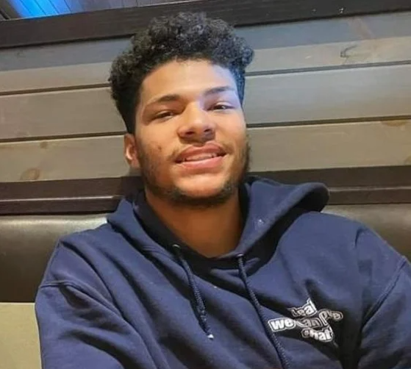
Kadin Black photo taken by Kara Patterson [source 1]

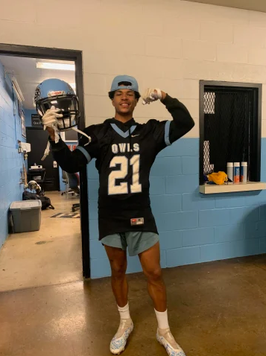
Kadin Black photo taken by Maurice Black [source 1]

